Analyzing Suicides in India - 2015

Contents

Introduction 2
Spatial Data Used 2
Tools Used 2
Maps Generation 2
Vector layer with state boundaries & ind_states table: 2
QGIS DB Manager and Postgres: 3
Joining Data 3
Graduated Maps 3
Web Map 3
Choropleth Maps & Analysis 4
Total Suicides: 4
Farming Related Suicides: 4
Farming Suicides per million hectare: 5
Web Map & Analysis 5
Summary 6

Introduction

When human dies, what if GOD asks: "So, how was the heaven?" Indeed, this life is a gift bestowed upon us by the creator. It is equally alarming to know that almost a million people end their own lives through the act of suicide! This is one of the most disturbing problems human race faces that can be tackled in better way by policy makers utilizing technologies at our disposal.

I am from India, the country with 17% of suicides in the world. In 2015, 133623 people committed suicides. 12602 (11%) of them were from farming sector.

Through this project, I am trying to highlight the distribution of total suicides (in 2015) in 36 Indian states. India being agrarian country with around 70% of its people directly or indirectly depending on agriculture sector, specific intention has been given to analyze farming related suicides.

Spatial Data Used

- Suicide Statistics: National Crime Records Bureau (http://ncrb.nic.in)
- Boundary Shapefile for states: http://www.diva-gis.org/gdata
- farming related statistics:
http://eands.dacnet.nic.in/PDF/Glance-2016.pdf
http://farmer.gov.in/agriland.aspx

Tools Used

- QGIS - open-source cross-platform desktop GIS application that supports viewing, editing, and analysis of geospatial data.
- Postgres (with Postgis) - Postgres is open-source RDBMS and PostGIS adds support for geographic objects to it.
- Microsoft Excel

Maps Generation

Vector layer with state boundaries & ind_states table:
Shapefile containing Indian state boundaries is added as vector layer in QGIS.
Then, we have saved this shapefile as geojson file (ind_states.geojson), with changing CRS from 4326 to Indian CRS 32645. This geojson is then loaded in QGIS as vector layer for all the maps used in this project.

QGIS DB Manager and Postgres:

Now, to do some database level manipulations, using 'DB Manager' we have imported ind_states.geojson file in Postgres as table "ind_states". We have created 'Spatial Index' during import. This is one of the best practices which will be effective in running ST_Distance and ST_DWithin queries on geospatial data.
From "ind_states" table, we have created a view "ind_states_view" with only columns we are interested in.
"ind_states_view" and CSV file "suicides.csv" with statistics about suicides is loaded as table layer in QGIS. This is to represent these stats on maps. We have used csvt files to upload CSV files in QGIS with proper datatype as delimiter text layer. We have renamed them in QGIS layer panel as 'states' and 'statistics'.
In suicides.csv file, filed nsa_khect is "Net Sown Area (NSA) in 1000 hectares" and suicides_pmh represents "suicide per million hectares of NSA"

Joining Data

Using 'Join' feature in QGIS, we have joined geojson vector layer with statistics and states tables.

Graduated Maps

Using available data, we have prepared 3 visualizations (maps): 'total_suicides', 'farming_suicides' & 'farming_suicides_pmh'. Class intervals and colors are chosen so as to make these maps self explanatory. However, this crucial task is a perfect blend of an art and science.
Here, we have not used any background layer and kept the view simple so as to focus carefully on the story these maps are telling us.
For all 3 maps, we have added labels for states and adjusted layer transparency to get better visual effect.

Web Map

We have prepared geojson file containing geographical locations, population and number of suicides in 53 major cities. We have used geojson.io website for this purpose.

Choropleth Maps & Analysis

Total Suicides:

Maharashtra, Tamil Nadu, West Bengal, Karnataka, Madhya Pradesh & Telangana are states with more than 10000 suicides in 2015. These are the states with population in the range from 35 million (Telangana) to 112 million (Maharashtra).
Chennai, Bangaluru, Mumbai, Pune, Hyderabad & Kolkata are major cities in these states which contribute to high numbers. We can say that fierce competition in day to day life in these thriving business hubs taking a toll by claiming lives of people who are on the receiving end of it.

Farming Related Suicides:

More than 1000 farmers ended their lives in each of Maharashtra, Karnataka, Telangana & Madhya Pradesh. Chhattisgarh, Tamil Nadu and Andhra Pradesh are next 3 states where farmer suicide rate is considerably higher. Rest of the 29 states are comparatively better for farmers.
Maharashtra is the state with highest total number of suicides (16970) as well as highest farmer suicides (4291). This is something of grave concern. On one side, cities like Mumbai, Pune, Nagpur and Nasik are growing on the other side rate of suicides is also growing. This potential correlation is alarming!
Most of the farming related suicides are in Western and Southern states. This is because of the fact that farming in these parts depend highly on monsoon rains. Significant change in monsoon pattern can cause adverse impact in these states.
We can see that West Bengal is right at top in terms of total_suicides (14602). However, farming related suicides are 0. This is related to the fact that most of the largest Indian rivers (7) flow through West Bengal to meet 'Bay of Bengal' throughout the year. This is why West Bengal is most flood prone state in India.

Farming Suicides per million hectare:

This map shows farmers suicides per million hectare of Net Sown Area. Puducherry is an exception to top this list with rate of 800 suicides per million hectare of NSA. Actually, it is one of the smallest Union Territory with population little over million. There are 12 farming related suicides for NSA of 15000 hectares (which is very less compared to are in other states). This is the reason for it topping the list.
Moving on to actual area of interest, Telangana, Maharashtra, Sikkim, Chhattisgarh, Tripura, Karnataka, Andhra Pradesh Tamil Nadu and Kerala are states with more than 100 farming suicides per million hectare of NSA.

Web Map & Analysis

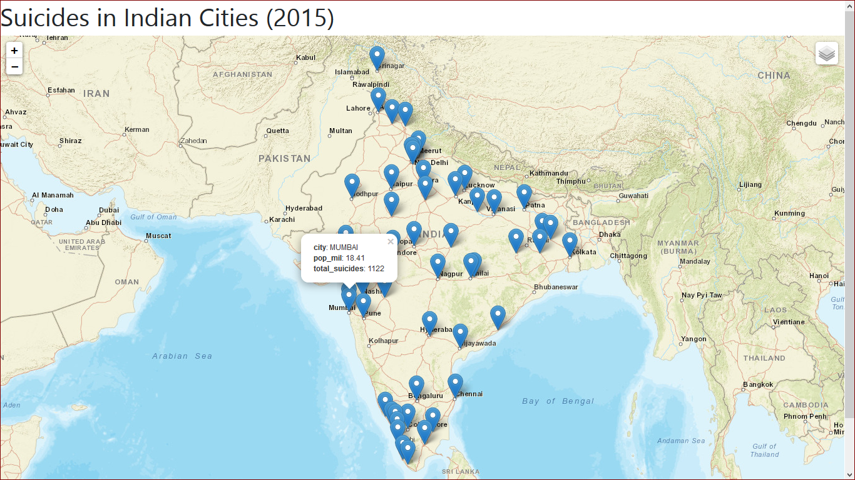

This webmap shows number of suicides in 53 major Indian cities. If we see carefully at the numbers, we see that situation in western and southern cities is worsening compared to that in eastern and northern cities (with the exception of New Delhi which is in Northern part and having very high number of suicides).
It would have been more informative to depict the picture using heatmap, if we had details of all places where suicide have occurred. We could also have done point in polygon analysis in that case. Lack of availability of data is a key concern in studies like this especially in highly diverse country like India with 1.3 billion inhabitants.

Summary

This moderate effort of analyzing suicides across Indian states can be improved with collecting more accurate and more granular level data. It would be an effort worth taking.
Activists and scholars have offered number of reasons for suicides: such as mental health, personal issues, financial issues, marriage problems, monsoon failure, high debt burdens, government policies and so on.

As an extension of this study, consolidating all the relevant data with various carefully chosen parameters, and visualizing it on maps will certainly reveal insights of paramount significance.

After all, Nothing is more precious than saving lives of our fellow human beings.

